DIY Real Estate Web Application – Stage 1

Human Computer Interaction

COSC 3P94

Group Members: Malcom McLeod, Sowmya Movva, Henry Tu

March 3, 2022

Table of Contents

User Requirements …………………… 2

Website Analysis …………………….. 5

Visual HTA for Websites ……………. 13

Survey ……………..…………………. 16

Personas ……………………………….23

Primary Persona ……………………….32

Storyboard ……………………………..35

|  |
| --- |
| User Requirements |

The user requirements for the purpose of this software implementation will involve observing key issues in order to determine the goals of the user. The follows issues will reveal an in-depth analysis of what the user requires, and the most useful tasks will be selected.

Role of Actor

There are three actors involved in a DIY real estate application which are the buyer, seller and real estate agent. The buyer and seller do not need a middleman like traditional real estate companies to facilitate the sale of a home. However, real estate experts employed by the application will be responsible for the legal paperwork and address any other concerns the other actors may have.

Security

There are many applications that allow for the sale of homes that do not belong to the rightful owner thus anyone is capable of selling any house. Thus, security is very important for all actors and the user should be provided with security. Privacy of the users is also important and both buyers and sellers should have to go through a verification process. Automation of the verification process may lead to security vulnerabilities thus the use of a human employee may be a solution. Proof of ownership should be provided before a home can be listed and be reviewed.

Services

The services that are presented will allow for independent buying and selling of properties as well as real estate services. This will also include workshops and tutorials intended to inform buyers and sellers on how to proceed without a realtor. Buyers must easily be able to browse house listings and find the information on them they need. They must be able to contact the seller and make offers to buy. Sellers must be able create and manage a listing. They need to be able to see any offers from buyers and be able to contact them. A real estate agent must be able to access deals in progress between buyers and sellers and view any information required for any paper and legal work.

Navigation

The site should be easy to navigate and allow for users to explore the site without having to log in at least in order to access services such as buying properties as well as learning about the services that the website offers. The user should not have to spend time learning how to use the interface in order to maximize learning about DIY buying and selling.

User Input

The user input will vary based on the role of the actor. All users will have to click, scroll and input data using a keyboard in order to interact with the interface. The sellers will have to provide personal information, upload photos and videos, information regarding the property which they intend to sell as well as verification of ownership. Buyers will also be required to provide personal information.

Personalization Tools

Adding a tool that allows user to favourite a house. Another option to personalize is to allow buyer to filter features and be notified of properties that are listed with the same requirements. Allow for various filters for searching.

Organization and Layout

Neat layout that reduces noise. Large icons that show few items at a time so that the interface is organized. Ensure to reduce features to avoid overwhelming users and add option for tutorials and instructions wherever possible but not always visible.

User Experience

Ensure that the user is happy to use the interface and minimize frustrations that would make the application difficult to use. Ensure they have access to help whenever

|  |
| --- |
| Website Analysis |

We will be looking at three different real estate websites and comparing them to gain a stronger understanding of our user’s needs. The websites we have chosen are Purple Bricks UK, Fairsquare, and Zillow.

Feature comparison

|  |  |  |
| --- | --- | --- |
| Purple Bricks UK | Fairsquare | Zillow |
| View listings  Book house evaluations  Search bar  Lots of filters  Bar to indicate search range  Video tour  Google Streetview  Floorplans  Save listings  Brochures for house listings  Sales performance tracker | View listings  Book appointments to sell  Free home evaluations  Cashback on home purchases  Search bar  Lots of filters (Types of Properties, # of bedrooms, square footage, ect.)  Bar to indicate range of costs  Favorites  Featured houses have a good layout  Email alert system  Sliding scale to show how much could be saved on commission  Book a showing  Free info sessions  Price history  Mortgage calculator  Dimension for each room | View listings  Sell with Zillow agent or yourself: “for-sale-by-owner” (FSBO)  Create your own listing  Can save liked listing which can be compared  Contact an agent  Price, tax history  Neighbourhood walkability score  View travel times to other locations  Lots of filters  3d tour  Rental listing  Request a tour  Zillow 360: Sell your house with a Zillow agent, find and buy house with a Zillow agent, finance with Zillow loan  Interactive map with draw area feature and show schools  Loans  Various calculators and additional resources  Agent Finder  Find open houses  Save searches  Services for rental property management and advertisement |

Purple Bricks UK

Purple Bricks facilitates independent sales of home between buyers and seller. It also provides local experts that further assist the user. Their property experts are only there to guide and help users, unlike traditional brokers who facilitate a lot of the processes themselves, which allows them to provide commission free service.

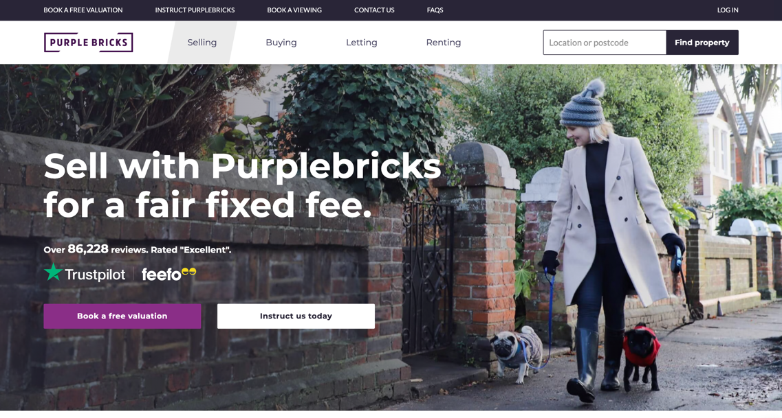

Overall, the Purple Brick’s layout is free of clutter and noise. It is quite simple and easy to read. Instructions are clear and concise which the user can expand on if required. The content is not feature-heavy and is easy for novice users while expert-focused features are hidden. When hovering over buttons, different options are presented based on the actor. This interface is designed for the intermediary users where some technical knowledge is assumed given that extra help is offered but only upon the request of the user. The content is not feature-heavy and is easy for novice users while expert-focused features are hidden. This interface is designed for the intermediary users where some technical knowledge is assumed given that extra help is offered but only upon the request of the user. Buyers are greeted by search bar and can scroll down the learn more about their services. Sellers are greeted by a link to book an evaluation and can scroll to see the pricing and services they offer.

Purple Bricks is fairly easy to use and is not bloated with features. It attracts new users by offering free valuations and simple instructions for first time users. It engages users that are curious about the service by not only targeting buyers and sellers but also those who are interested in learning more about independent real estate sales. There are several filters to help buyers search for the right home for them. A radius slider allows them to adjust how far from the searched location to filter and it gives users a better understanding of the distance. The listings are presented in rows of two. They have a picture, the price, address, number of bedrooms and the blurb of the full description. The picture is on the small side and the blurb is only a couple sentences of the description, so it is more distracting than helpful. It would be better off with a larger picture and providing the size and number of bathrooms.

On the proper listing page, there are lots of images for buyers to scroll through. The window with the map can be changed to a built-in map as well as Google Street view and even the floor plan. Some properties also have a video tour section that is essentially a walk-through of the home. These features allow prospective buyers to get a detailed view of the house without having to visit. Each page has key features in bullet points and a fairly lengthy description. For those just browsing, it takes more effort to view all the property has to offer. Instead of full sentences, icons could be used to show the amenities included, making it quick to digest. There is also a save feature so logged in users can come back to a listing.

Fairsquare

Fairsquare is a Canadian website with services offered in Ontario, Alberta and Manitoba. They offer commission free sales as well as offering $2,00 in cash back when buying through them. The website, however, seems to be geared more towards buyers than sellers with the latter requiring appointments with Fairsquare’s realtors. They have their own real estate agents so the site wouldn’t be considered a do it yourself/ independent site. As such, their real estate agent interface isn’t available to us and the public. This is not completely commission-free but more reduced commission. This does not completely cut out the middleman, the realtor still does a lot of leg work especially for the sellers. They still Take pictures and organize viewings through the website.



The Fairsquare website is poorly organized as lots of buttons are hard to find or are ambiguous. When prospective buyers click the buy button at the top nav bar, it leads to a page explaining their buying process rather than their listings. Instead, the listings are under the search page which may be frustrating for users than are unfamiliar to the internet. The listings are fairly well organized, giving basic information for the user to scroll by. In addition, the nav bar is always present, which can be distracting and takes up additional screen real estate. While buyers can start browsing without an account, sellers must request a call back before they can continue.

While Fairsquare has many features to help their users buy a home, there is clutter and bloat that negatively affects the user experience. First and foremost, the website has an unnecessary number of ads which gets in the way of the website’s functionality. On the listings page, there is a self-scrolling list of free info session dates however, presumably due to the Covid-19 pandemic, they are all listed as online. This could be placed in a different location as possibly in a different format, such as a calendar. Fairsquare allows you to view listings on a map, similar to Zillow as discussed below. However, unlike Zillow, the map is not very intuitive and not provide a list of homes in the viewed area on the map. Instead, you must click on the location of homes on the map to view them and it requires you to be zoomed in to a neighbourhood level zoom to be able to click on individual houses. Once you click on a home on the map, a preview pops up, similar to the traditional listings but the preview doesn’t fit within the map windows and thus must be scrolled through. The map toggle switch is also not well visible, which is perhaps for the best. Many listings have a section labeled Internet + TV on their page. But many home listings that do have this section have it blank and one that did have content in it was just essentially and ad listing from one of the companies that were available to provide service to that house. The site also seems to perform poorly, being slow to load which is a further turn off. This could be related to the number of ads on screen.

Despite some of the shortcomings, Fairsquare still has some useful features. There is a fairly comprehensive set of filters for searching. There is a slider for the price which gives the user a better feel for the price range. They have a favourites system as well as an email alert system so those with serious interest in certain listings can make sure they can return to their page. There is also sliding scale to show how much could be saved on commission. While browsing, individual listings have minimal information, with icons for bedrooms, bathrooms and size. The full listing page has additional information such as price history and a mortgage calculator. Finally, Fairsquare also offers free home evaluations for buyers.

Zillow

Zillow is a real estate website that allows users to buy and sell homes with the help of Zillow’s agents. It also allows for individuals to buy and sell independently without the use of a broker. It makes browsing properties for sale easy for buyers with its map-focused interface that allows you to look for houses by location. However, you can still scroll through the listings traditionally with filters to help you sort through them.

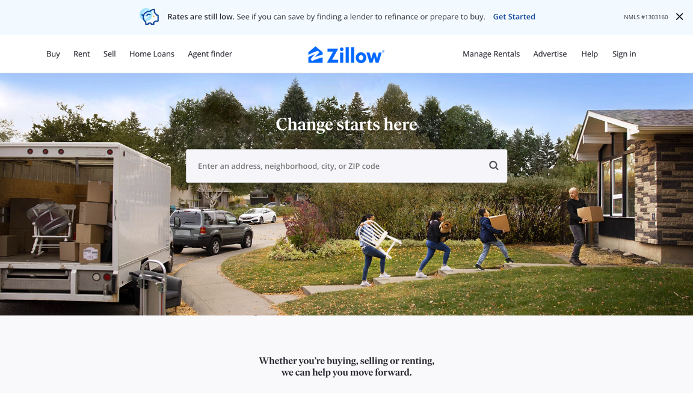

The website is easy to navigate with the menu at the top allowing you to select whether you are buying, selling, and more. The navigation menu might have more than the ideal number with nine buttons, it is not overwhelming to look at. They also have sub-menus if you hover over their respective buttons providing additional features that do not clutter the main navigation bar. The listings page is split between an interactive map on the left and listings more traditional house listings on the right. Browsing the listings is easy as it provides only basic information: a picture, size, numbers of beds and baths, the address, and the relator information if applicable. Though it could be argued that the realtor information is unnecessary on the list of houses as it adds more text to scroll through. Information unique to the listing may be placed in the corner of the image letting users know when there are open houses or if the listing is leaving Zillow soon. Instead of opening a new page when clicking on a posting, a window pops up over the map. This allows you to exit the window and return right to where you were previously browsing. For buyers, they just need to enter a city or location in the search bar and select buy and they are easily brought to the listings for that location. However, Zillow is designed for both traditional broker transactions as well as “for-sale-by-owner” (FSBO) listings. It seems to put their own brokerage services before FSBO services, and you need to scroll down the sell page to find the option and is not as simple as buyers looking at listings.

They have many helpful features to help you find your home. The simplest being the heart button allowing you to favourite listings provided you are logged in to an account. The map that was previously mentioned can also list nearby schools. Instead of searching a city, one can also circle an area on the map to search for, being flexible for the needs of the users. There are also many filters such as price, number of rooms, type of building and more. One of the more unique features of Zillow is the 3D tours, where for certain houses you can look around a 3D model of the house like a dollhouse. You can also see the various rooms inside and move around like Google Street View. The virtual tour gives you a much better understanding of the house than just regular photos. When creating your own posting, there are some helpful checks in place such as if the system believes you are entering a price that is significantly lower than what the average price is then it will give you a warning. Whether or not there are additional helpful features for sellers can’t be seen without actually submitting a listing.

Zillow’s website offers lots of tools for those in the real estate market, however, some are not as useful. Some additional features have empty sections for some locations. With the location set to St. Catharine’s, there are no foreclosures available nor are there any homes not sold by an agent. Under the agent finder where you can find various services related to buying and selling homes, there are no results for property managers, builders and more.

|  |
| --- |
| Visual HTAs For Websites |

Fairsquare

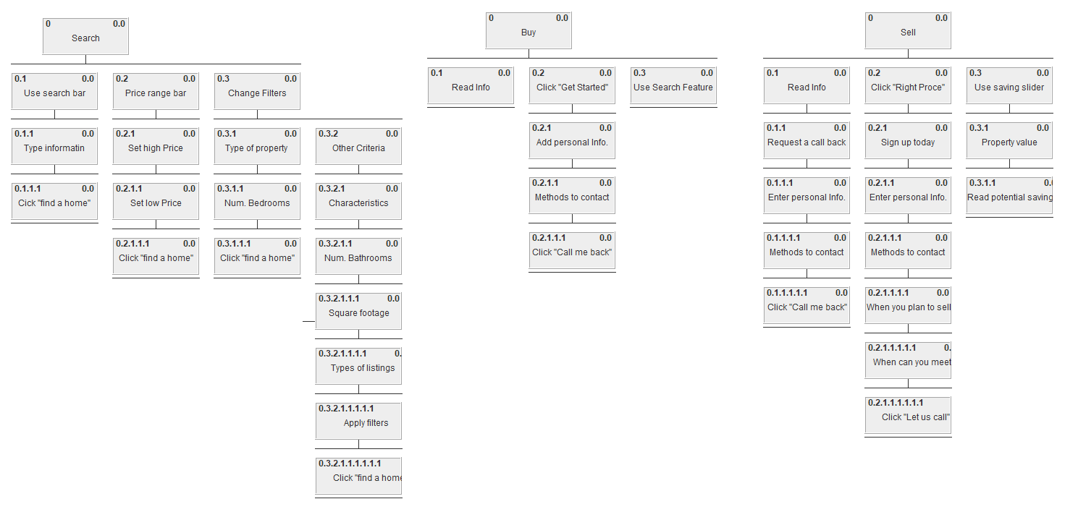

Zillow

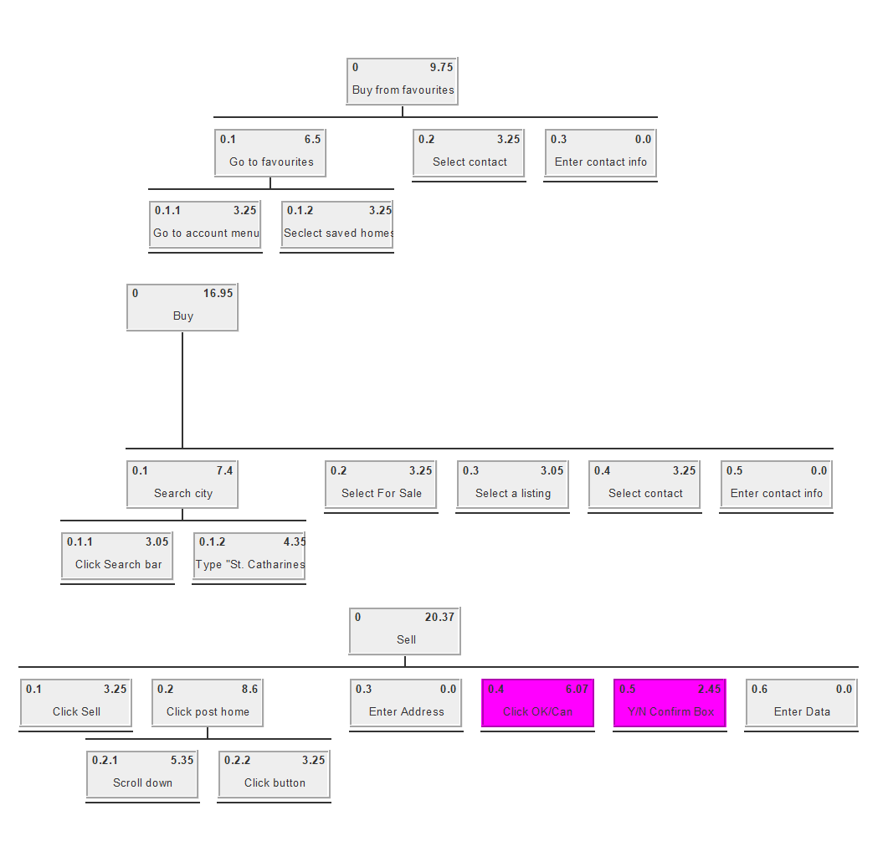

Sample HTA of uses:

Buying from a previously favorited listing

KLM: MPHKS MPHKS MPHKS

Buying from a listing

KLM: MPHK MKKKKKKKKKKKKKKS MPHKS MPHK MPHKS

Selling your home

KLM: MPHKS MR MPHKS MPHKS MPHKS

|  |
| --- |
| Survey |

The survey assessed 25 participants based on a series of questions regarding housing and real estate.

The age of the participants ranged from 20-50 with a few outliers but most of them fell within the intermediary user group.

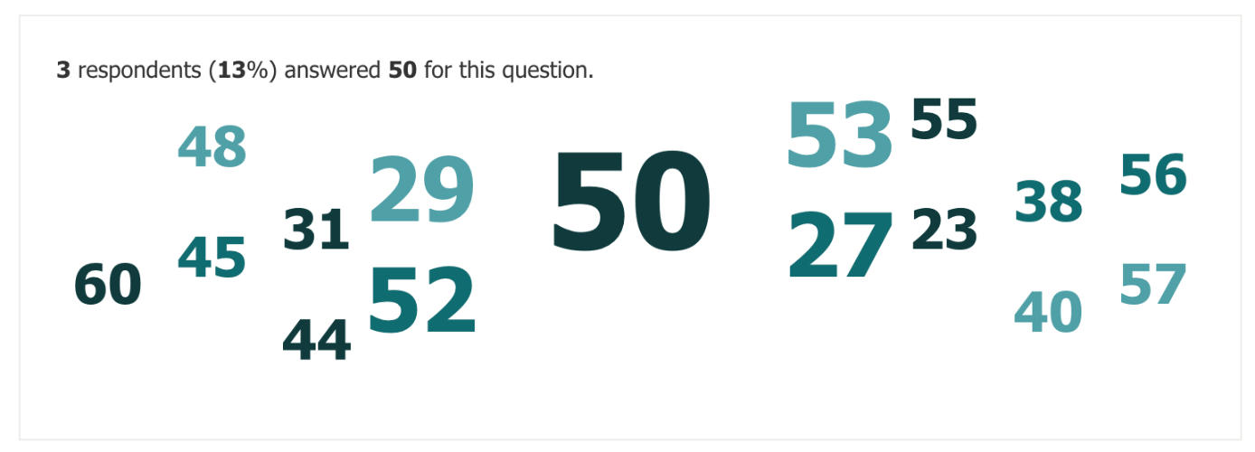

The gender of the participants also varied with an almost equal number of males and females and a few that preferred not to answer as well as non-binary individuals.

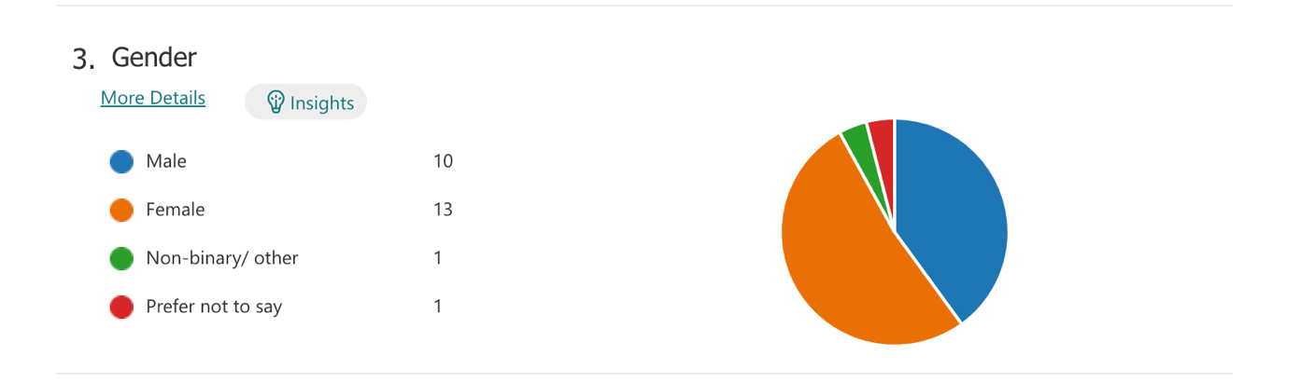

The professions of the participants also varied with many in the healthcare industry, IT, teaching, corporate, skilled trades and etc. There are a large variety of occupations which ensures that there was no bias towards a single profession.

Most participants felt that they were good with technology thus majority of users are intermediary users whose primary device is a phone or a laptop.

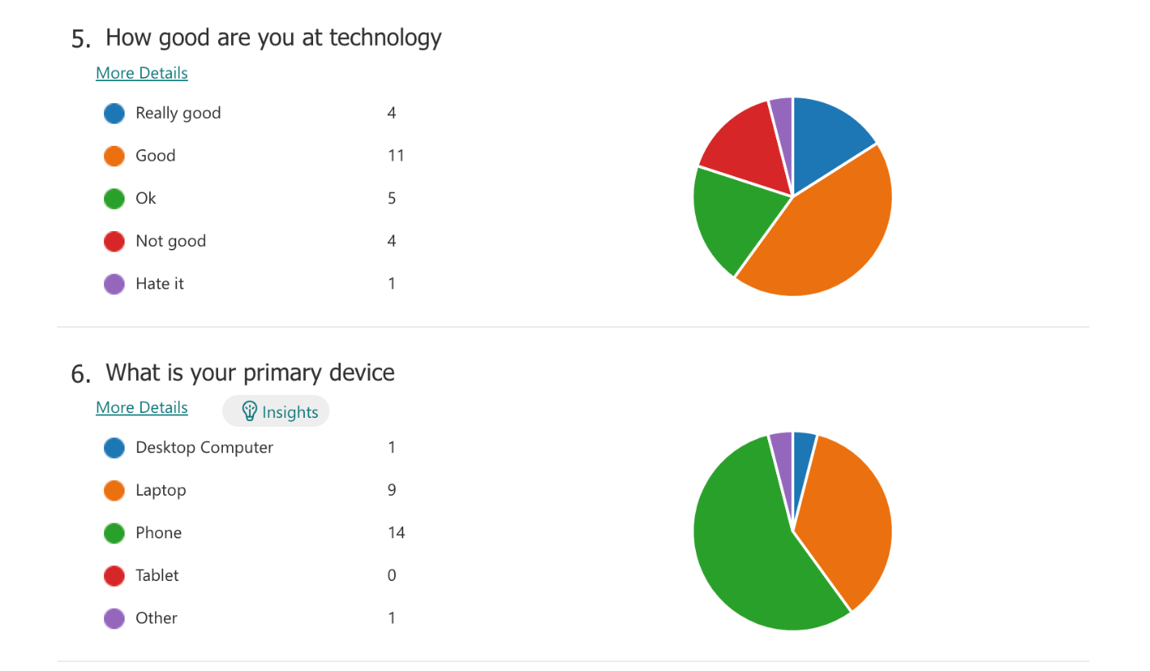

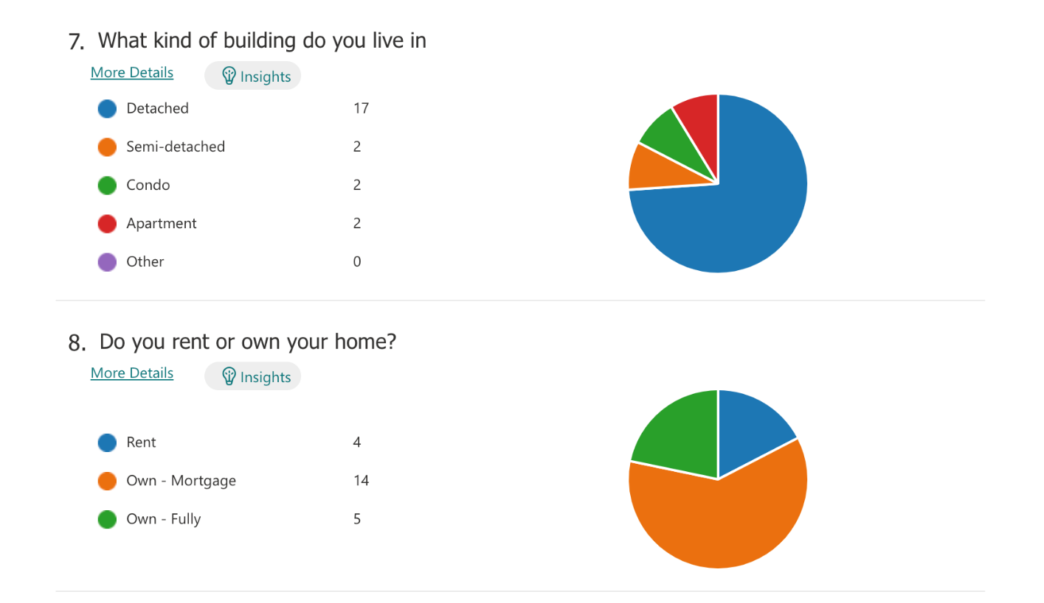Most participants resided in a detached home that they own but is being mortgaged.

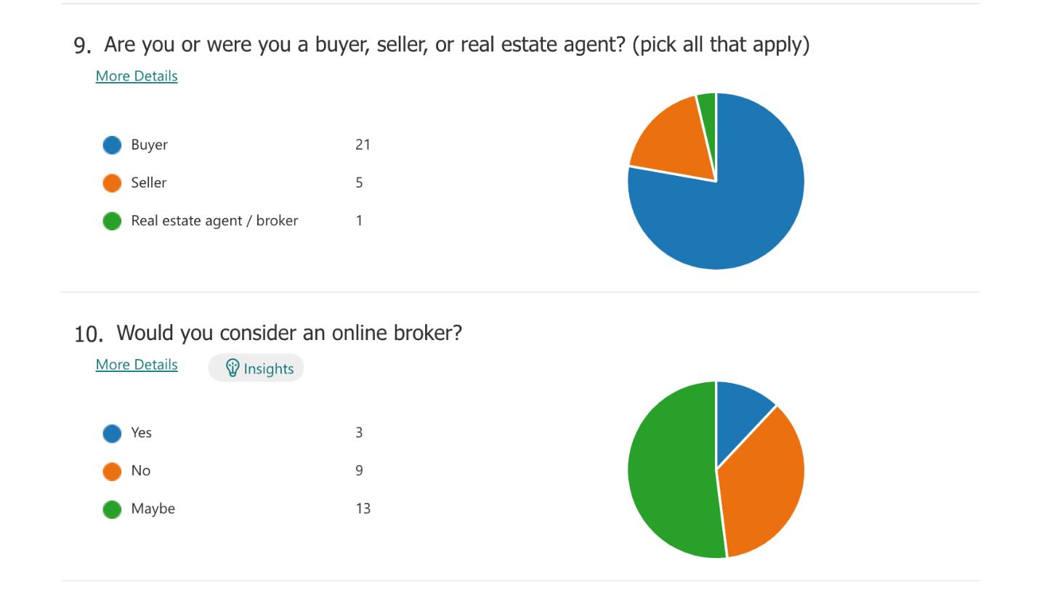The majority of participants that were surveyed were buyers and more than half answered that they may consider online brokers. A sizeable portion said they would not consider an online broker and only 12% said they will consider an online broker. This indicates that there is hesitancy to shift from traditional real estate brokerages. The participants that indicated that they may consider an online brokerage were interested in saving money due to the current unaffordable housing market. Those that responded with no stated that they were not good with technology, did not have free time, had cultural barriers, or it was their first home, and they are not familiar with real estate procedures.

When asked about what features people are looking for in a DIY real estate website, many wanted information that is provided when consulting a traditional real estate firm such as an agent that are able to speak to as well as booking tours of the house. Many also expressed that they wanted more information regarding the process such as tutorial or demonstrations.

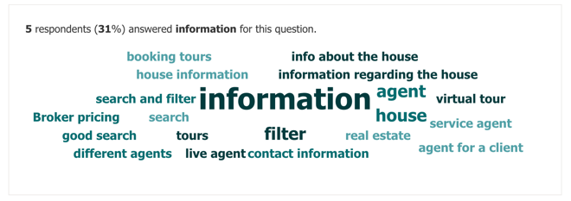

The average time that people spent looking for houses was a few months. They typically took their time with searching for houses.

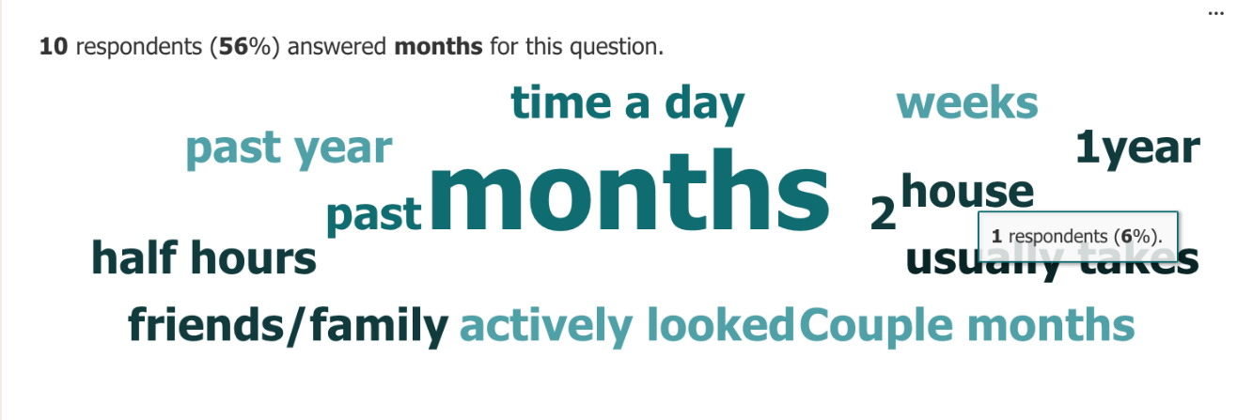

Many also considered location as an important factor that would determine whether or not they are willing to considering a house.

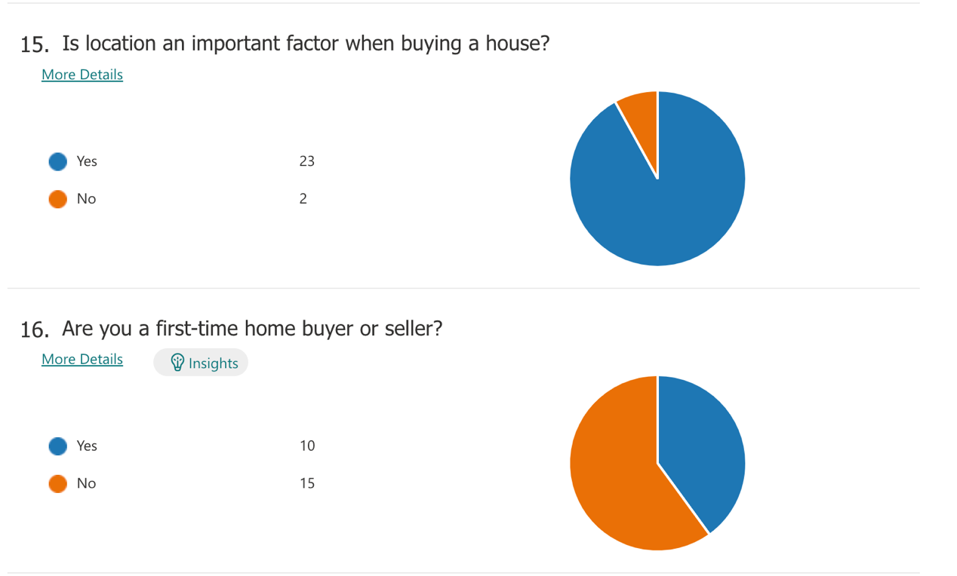

Although the answers to this question were varied, two things that most people look for in a house are cost and location.

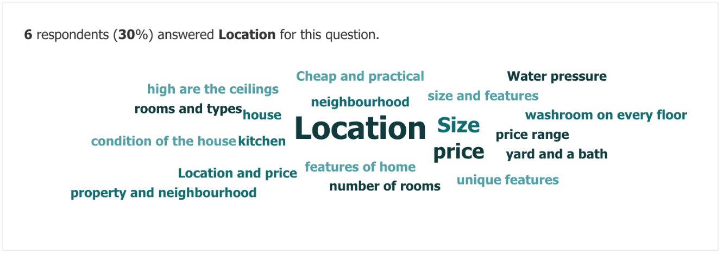

Most people described having very little free time with most people citing less than 20 hours per week.

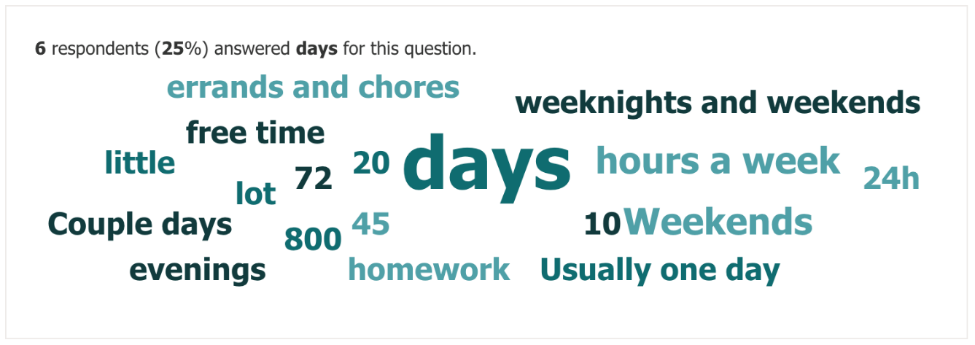

When describing strengths most people cited strong communication and interpersonal skills. For weaknesses, the most common answers were that people were bad with technology and multitasking.

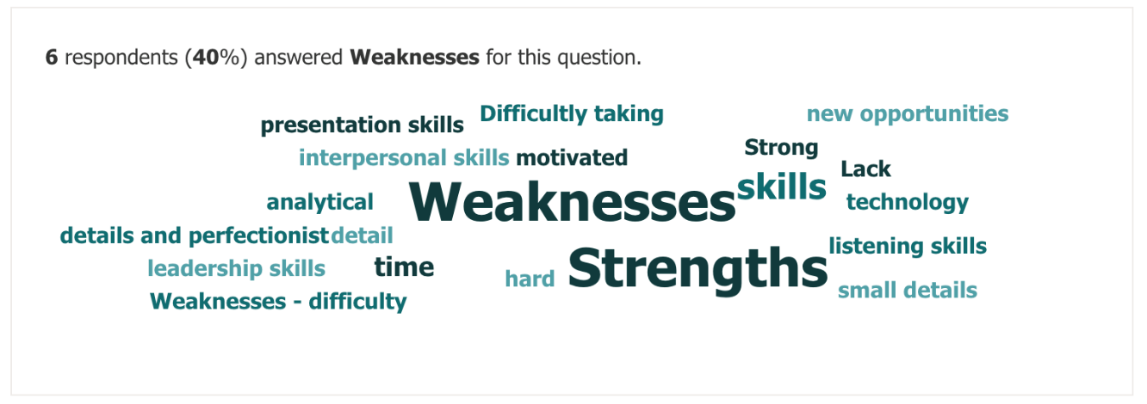

When asked about personal goals, the most common answer was retirement, but two other notable answers were to become a first-time home buyer or to sell their current home and move to a new house.

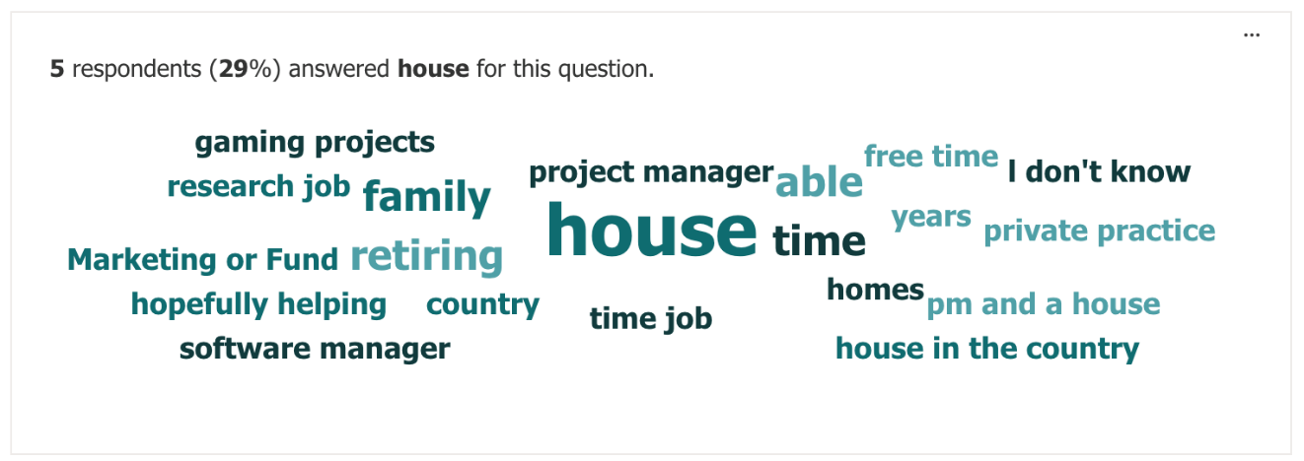

When asked about hobbies a common answer was to watch television or stream some other form of entertainment. Overall, participants had a wide range of hobbies but an number of these interests involved technology.

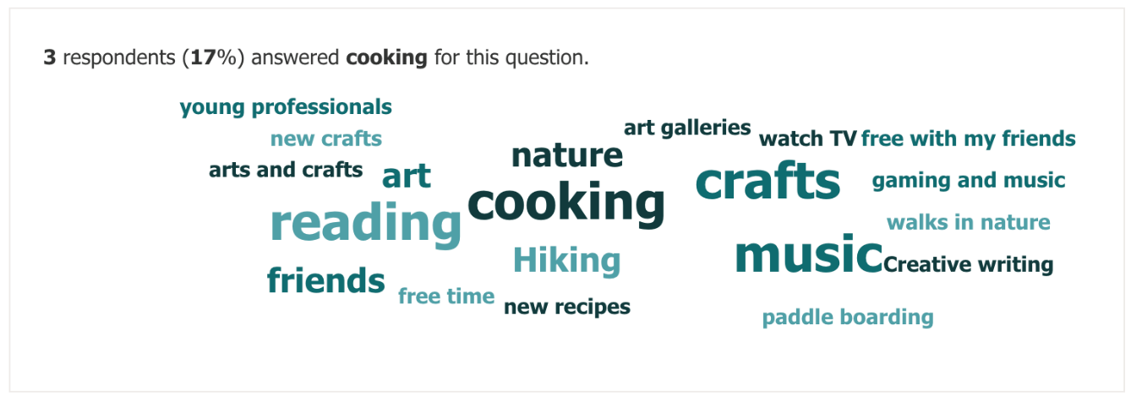

|  |
| --- |
| Personas |

# Chloe Decker



Bio:

Age: 28

Occupation: Software Engineer

Income: $120,000

Personal Info:

Young working professional looking to move away from her busy downtown lifestyle to a quiet suburb located in the outskirts of the city. She is hardworking and career driven.

Personal Goals:

Become a software manager for her department and receive a promotion. She is also starting her fitness journey, but her busy lifestyle has interfered until her job only required employees to work remotely.

Immediate Goals:

Move away from downtown given the rising costs and inflation. She is also looking to purchase a new vehicle and start a healthier lifestyle.

Habits, Behavior and Interests:

She does not have too much free time but enjoys cycling as it is her main method of transportation. She also attends Zumba classes at her local gym and is looking to explore fitness. She enjoys spending her free time with her friends and socializing.

Frustrations:

Frustrated when time is wasted and is not patient.

Skills:

Strong interpersonal and technical skills. Speaks many languages and is a fast learner.

Technology:

Highly skilled with technology given her profession and is considered an expert user

Social:

She is a very social individual and spends most of her free time at the gym or with friends trying new restaurants

# Alex Stevens

Bio:

Age: 38

Occupation: History Teacher

Income: $60,000

Personal Info:

Married with one teenage son and a successful secondary school teaching career

Personal Goals:

His 16-year-old son is looking into post-secondary schooling options thus he wants to save for his education. He entered the workforce late as he had children at a young age thus is looking to save for retirement.

Immediate Goals:

He is looking to invest in a second house for rental income in order to save for retirement and help his son with his education.

Habits, Behavior and Interests:

Football enthusiast that does not miss a single game and coaches kids’ football at the local school on his free time. Also collects football items as well as plays fantasy football

Frustrations:

Frustrated with technology and economy. Concerned that robots are stealing jobs and does not like change.

Skills:

He is very hands on and is great at fixing things around the home.

Technology:

Mediocre with technology and could improve but relies on his son and wife for help.

Social:

Not good with strangers but comfortable with people he knows.

# Bobby Welland



Bio:

Age: 60

Occupation: Accountant

Income: $50,000

Personal Info:

He has been married for 35 years and has three adult children. His family and friends jokingly call him stingy for his cautious spending habits.

Personal Goals:

He is looking to retire within the next five years and keen to become a grandfather. He also wants to spend more time with his wife and family.

Immediate Goals:

He wants to downsize and sell his old home as he will no longer need such a large home after retiring. He also wants to help his kids settle down.

Habits, Behavior and Interests:

He likes gardening and crafting. On his free time, he makes wooden dolls and knits custom sweaters for cats.

Frustrations:

He is frustrated by expenses and large fees as he has a financial background.

Skills:

He is skilled at crafts and is known for his creativity. Great with pets and children given his compassionate nature.

Technology:

Bad with new trends and change in technology. He is good with the familiar software that he uses at work but otherwise not technologically savvy.

Social:

Extroverted and hospitable person.



# Anushka Dube

Bio:

Age: 25

Occupation: Marketing Specialist

Income: $60,000

Personal Info:

Recent university graduate and has been offered a role as a marketing specialist at a firm that she interned in when she was pursuing her undergrad.

Personal Goals:

She is looking to settle down and transition into full time work. She also wants to focus on her artistic hobbies which will also benefit her career so that she can create her own digital marketing firm.

Immediate Goals:

She wants to move out of her student house and into her own apartment. She wants to cut costs by living with roommates in order to save for her own house.

Habits, Behavior and Interests:

She also enjoys swimming and theatrics on her free time.

Frustrations:

She is passionate but lacks the time and space to pursue her interests. Thus is limited for the time being with establishing a firm.

Skills:

Artistic and very skilled at digital art and graphic design. She is also easy going and works well under pressure.

Technology:

Skilled with technology especially graphics and digital design software.

Social:

She is a very social individual and spends most of her free time at the gym or with friends trying new restaurants



# Sergey Markovic

Bio:

Age: 27

Occupation: App Developer

Income: $50,000

Personal Info:

Lives in an apartment with a pet cat and his roommate. He is currently single and does not have any children. He is a freelance app developer and works part time as a barista.

Personal Goals:

He received a big bonus from large client recently but is still looking for stable employment. He wants to break into the housing market but is struggling with rising cost of living and unaffordable housing.

Immediate Goals:

He is looking for a stable full-time job that will allow him to work less hours and have free time.

Habits, Behavior and Interests:

Not much of a social life as he is typically spending most of his time working but he does have a group of friends he plays video games with on a regular basis.

Frustrations:

frustrated when apps are not designed well/intuitively. Does not like callous decisions and likes to have as much information as possible before making a decision.

Skills:

Excellent multitasking abilities and very motivated

Technology:

Great with technology and notices immediately improvements that can be made immediately.

Social:

He is outgoing and great with clients but not have time for socializing outside of work.



# Rita D’oro

Bio:

Age: 58

Occupation: Garden Centre Owner

Income: $500,000

Personal Info:

Successful entrepreneur that owns a large nursery in a populous city. She is semi-retired and has been working part-time for the past 10 years. She lives with her partner on a rural property and does not have any children.

Personal Goals:

She is looking to establish new locations across other major cities in the province as well as start gardening and birdwatching classes.

Immediate Goals:

She wants to sell her old condo as it has been unoccupied since moving in with her partner.

Habits, Behavior and Interests:

She has a green thumb and enjoys spending her time outdoors. She is also a wine enthusiast and has a vast collection.

Frustrations:

She is frustrated with climate change and rising pollution levels across the globe. She is deeply concerned and is trying to spread awareness among local groups.

Skills:

She is very hands-on and calm.

Technology:

Not good with technology and believes that their eco footprint outweighs the benefits thus does not use it unless it is work related.

Social:

She is an ambivert and needs time to recharge her social battery. She enjoys spending time at home but is outgoing when pursuing hobbies or at work.

# Jerry Nguyen



Bio:

Age: 44

Occupation: Construction Worker

Income: $70,000

Personal Info:

Lives with his boyfriend in a rented condo and pursuing part time studies in management.

Personal Goals:

He has been working in construction for the past fifteen years and has been saving for a down payment on to purchase his own condo. He also wants to enter construction management and is looking to advance his career.

Immediate Goals:

He wants to get married to his longtime partner and adopt children.

Habits, Behavior and Interests:

He enjoys running and training for marathons. He also hosts book clubs for marginalized communities and donates proceeds to charitable organizations.

Frustrations:

Frustrated with lack of development for marginalized communities and is easily irritable after his injury as he has been taking time away of work to recover.

Skills:

Passionate and motivated about social change.

Technology:

Considered a novice user of technology and mainly uses social media.

Social:

Introverted but easy to approach due to his kind and helping nature.

# Joanne Kelp

Bio:

Age: 48

Occupation: Occupational Therapist

Income: $110,000

Personal Info:

Married with two kids that are currently pursuing post-secondary studies.

Personal Goals:

Her career is going well, and she is content with her life. She wants to research new and emerging therapy trends and create a niche practice inspired by a rare disease her mother has developed.

Immediate Goals:

She wants to help both of her children buy their own properties after graduating university. Real estate is quickly becoming less affordable for younger generations, so she is worried for her kids’ future. She also has to save for her retirement, so she is careful with how much money she spends.

Habits, Behavior and Interests:

She enjoys spending her time with friends and family and organizes frequent gatherings. She also likes watching movies and going on daily hikes with her husband and dogs.

Frustrations:

She is frustrated with the rapid economic changes and inflation. She is worried for her kids and other young people.

Skills:

Highly skilled with technology given her profession and is considered an expert user

Technology:

Good with technology and learns quickly when she is taught by others. She uses her laptop frequently to find research on occupational therapy trends.

Social:

Ambivert that enjoys spending her time with friends and family but also needs alone time to focus on her goals and recharge.

|  |
| --- |
| Primary Persona |

# A picture containing person, wall, standing, suit Description automatically generatedJoanne Kelp

Bio:

Age: 48

Occupation: Occupational Therapist

Income: $110,000

Personal Info:

Married with two kids that are currently pursuing post-secondary studies.

Personal Goals:

Her career is going well, and she is content with her life. She wants to research new and emerging therapy trends and create a niche practice inspired by a rare disease her mother has developed.

Immediate Goals:

She wants to help both of her children buy their own properties after graduating university. Real estate is quickly becoming less affordable for younger generations, so she is worried for her kids’ future. She also has to save for her retirement, so she is careful with how much money she spends.

Habits, Behavior and Interests:

She enjoys spending her time with friends and family and organizes frequent gatherings. She also likes watching movies and going on daily hikes with her husband and dogs.

Frustrations:

She is frustrated with the rapid economic changes and inflation. She is worried for her kids and other young people.

Skills:

Highly skilled with technology given her profession and is considered an expert user

Technology:

Good with technology and learns quickly when she is taught by others. She uses her laptop frequently to find research on occupational therapy trends.

Social:

Ambivert that enjoys spending her time with friends and family but also needs alone time to focus on her goals and recharge.

Decisions made when constructing this persona were based on the data provided from our survey. The majority of the respondents had professional occupations and the average age was between 40 and 50. Although personal income was omitted as a survey question, it was interpolated from the answers given. It was decided that most respondents were earning a livable wage or higher and the income of the primary persona was chosen to reflect this. When asked about skills with technology most respondents answered that they were very competent. Most respondents also indicated that they were hesitant to use online brokerage, and that they would need sufficient financial incentive to do so. This was used to fuel the decision to make the primary persona drawn toward the website by the potential savings that could be obtained. When asked about career goals a common answer was retirement within the next five years. The primary persona therefore is looking toward retirement within the near future and is looking to support her children in their endeavours to enter the housing market. This further solidifies her financial incentive to use a brokerage website.

Joanne Kelp is the primary persona as she is considered an intermediary user that is comfortable using technology and is a fast learner when she is taught by others. She is a middle-aged woman with older children that are looking to enter the housing market within the next five years. She is already a homeowner but wants to help her children purchase homes. Given the rising cost of living which has been a primary concern for many people that are looking to enter the housing market for the first time, she has to remain cognizant of her expenditure given that she also needs to prepare for retirement. Although she is comfortable with technology, many users will be hesitant to switch to online brokerage as purchasing a home is an a very important decision that requires a lot of time and patience. Many are unfamiliar with the legal procedures of real estate as it has traditionally been done by middlemen that are employed by large brick and mortar real estate firms.

She does require help when learning new technology thus it is important for the interface to resemble technology that intermediary users are already familiar with. Combined with the complex and inaccessible nature of real estate procedures and the potential for a large gap to exist with the gulf of execution, this may act as a deterrent for many young first time home buyers, older users, and wealthier individuals who value their time. The incentive for Joanne is that her children can help bridge the knowledge gap when she struggles with learning or does not have time while also saving money on commission fees.

Storyboard

Homepage

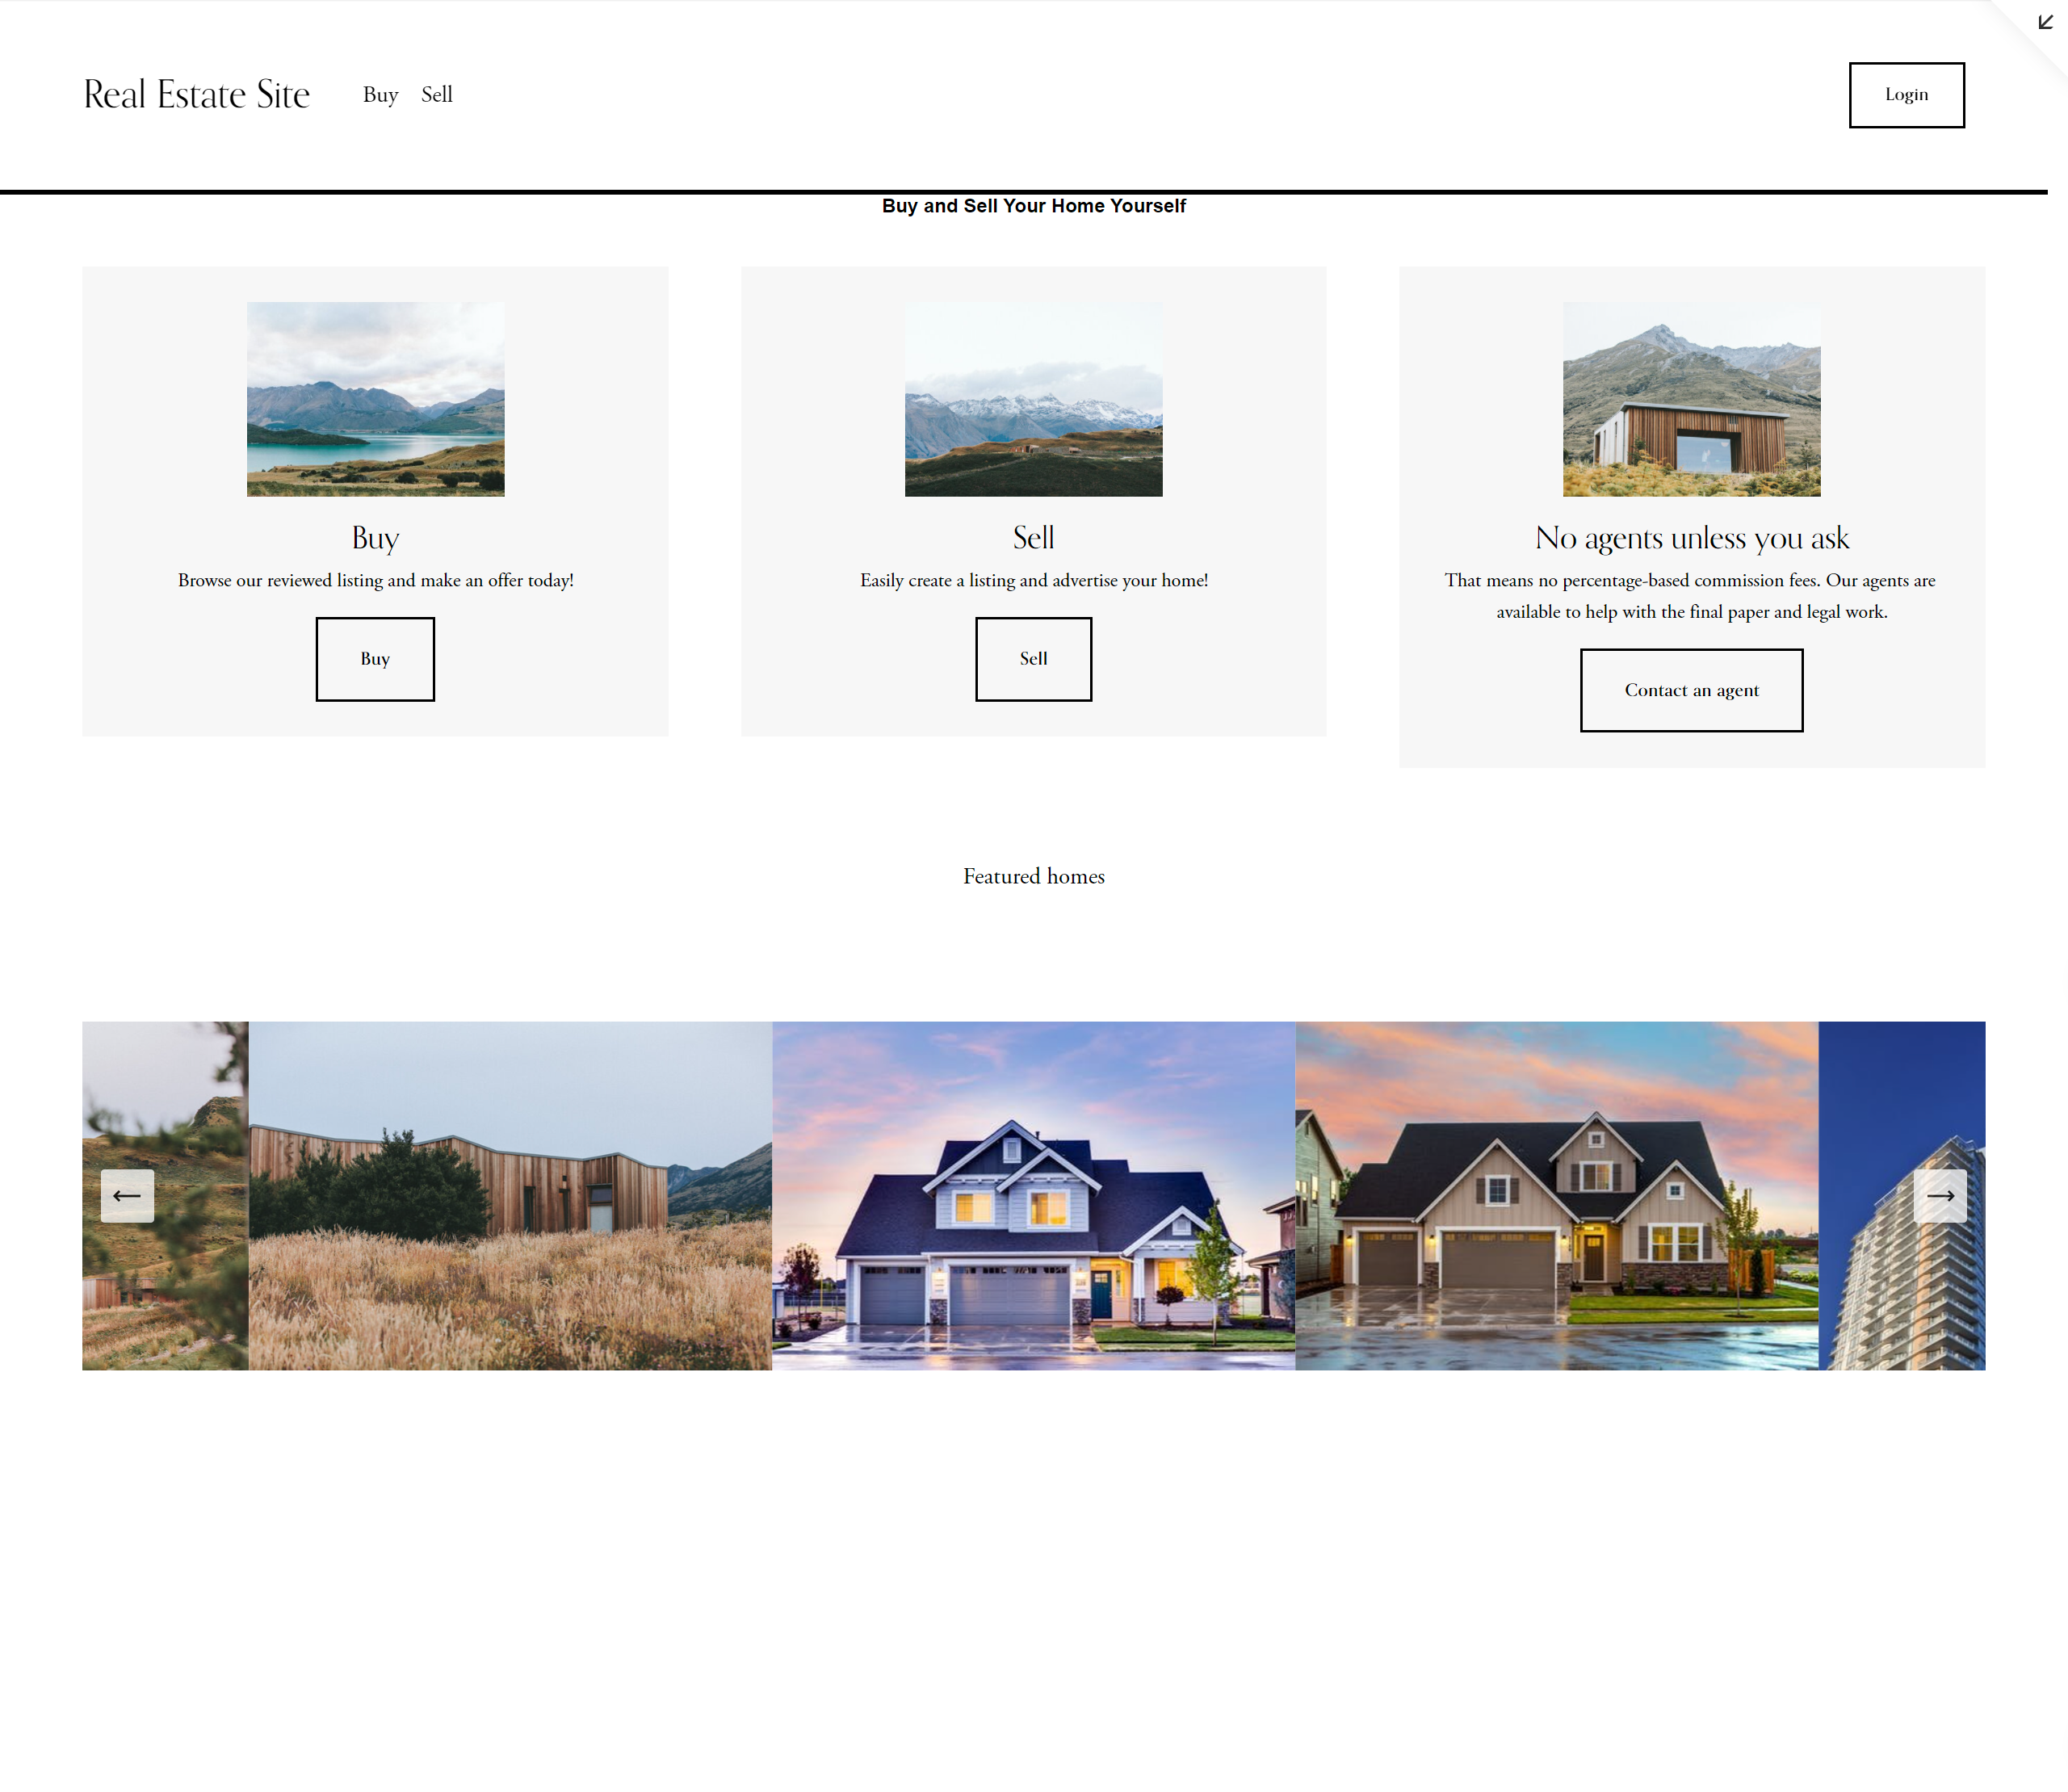

Buy screen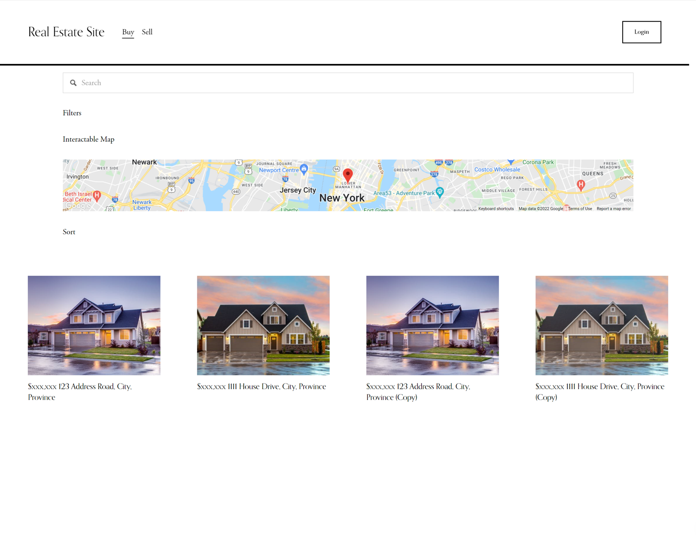

Sample listing

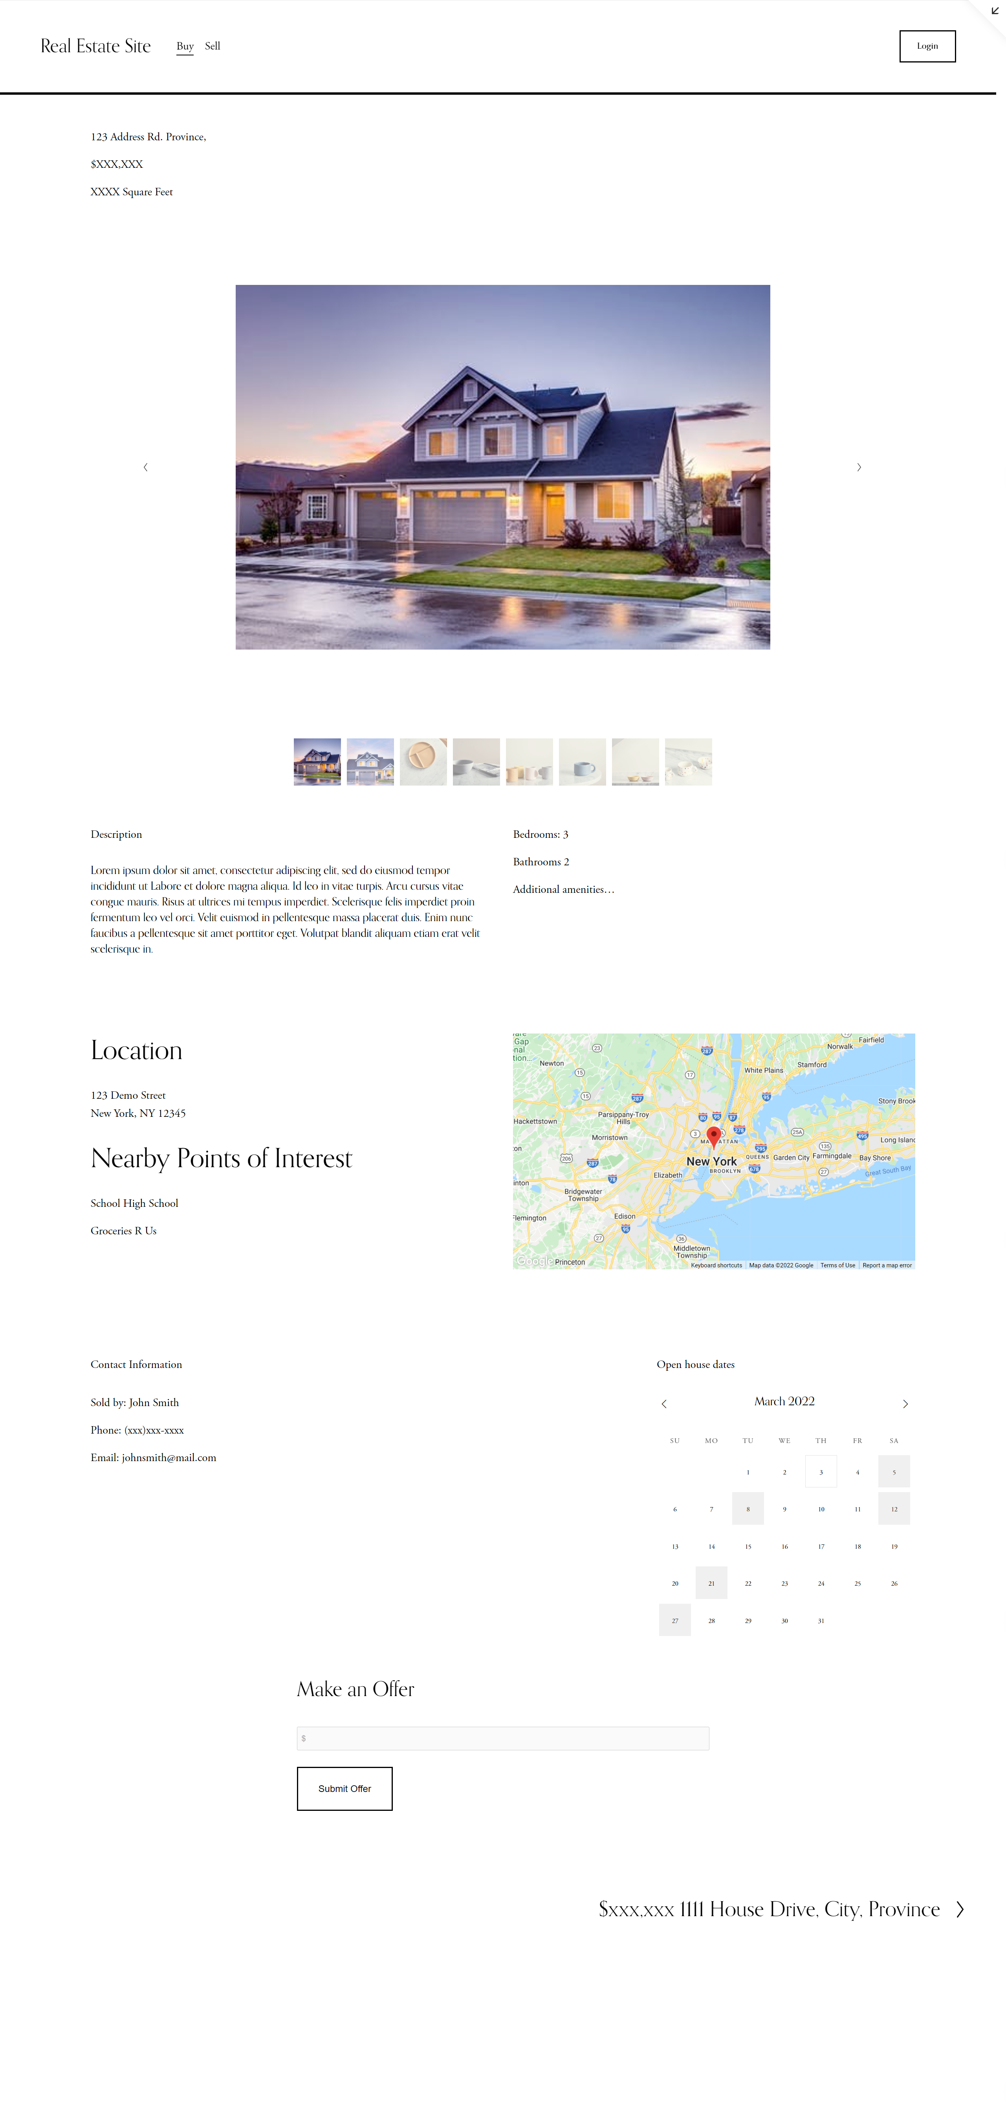

Selling: create a listing

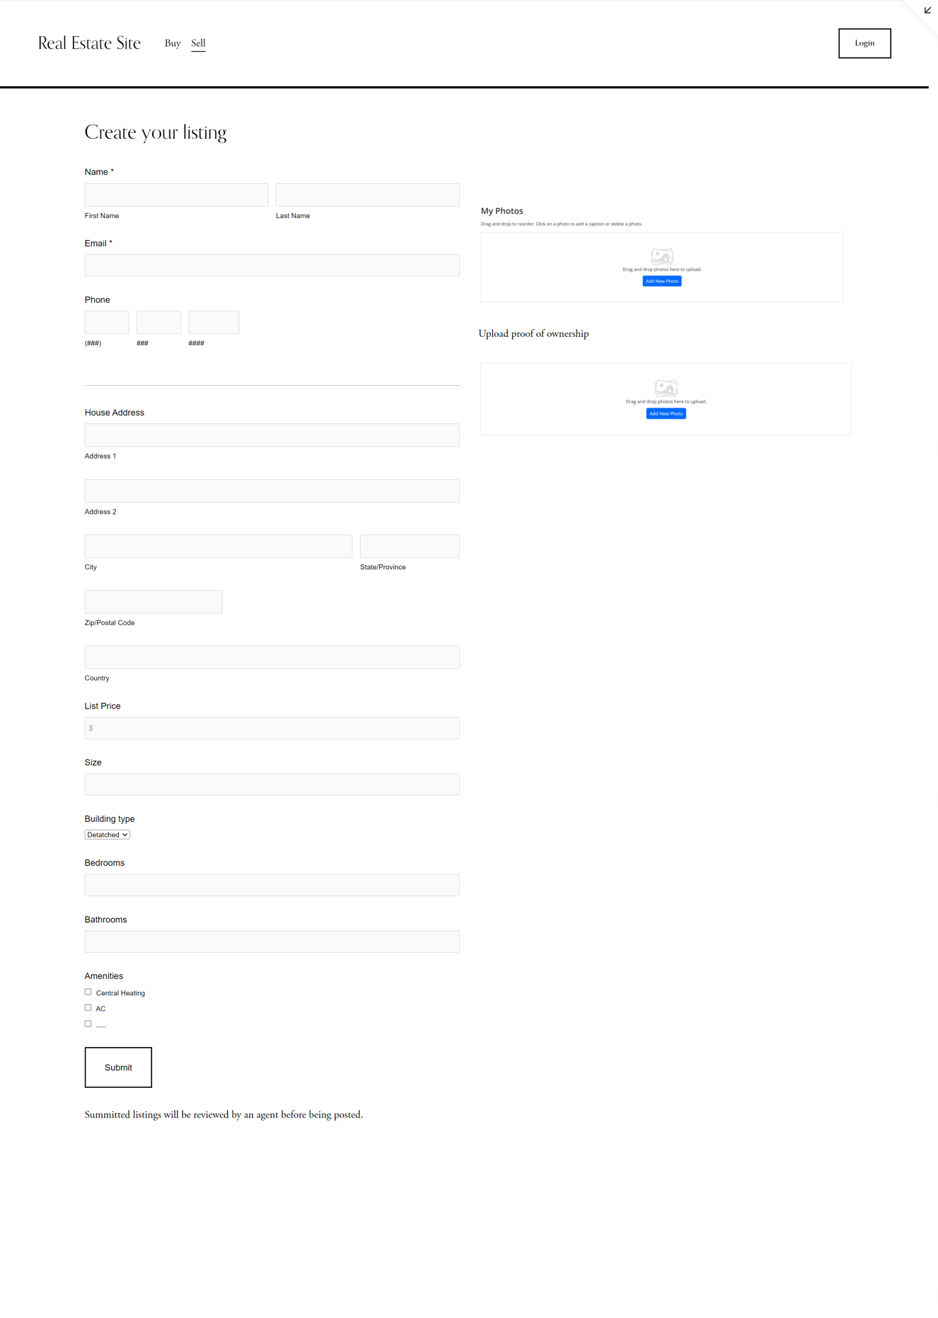

Selling: Your listing/ your offers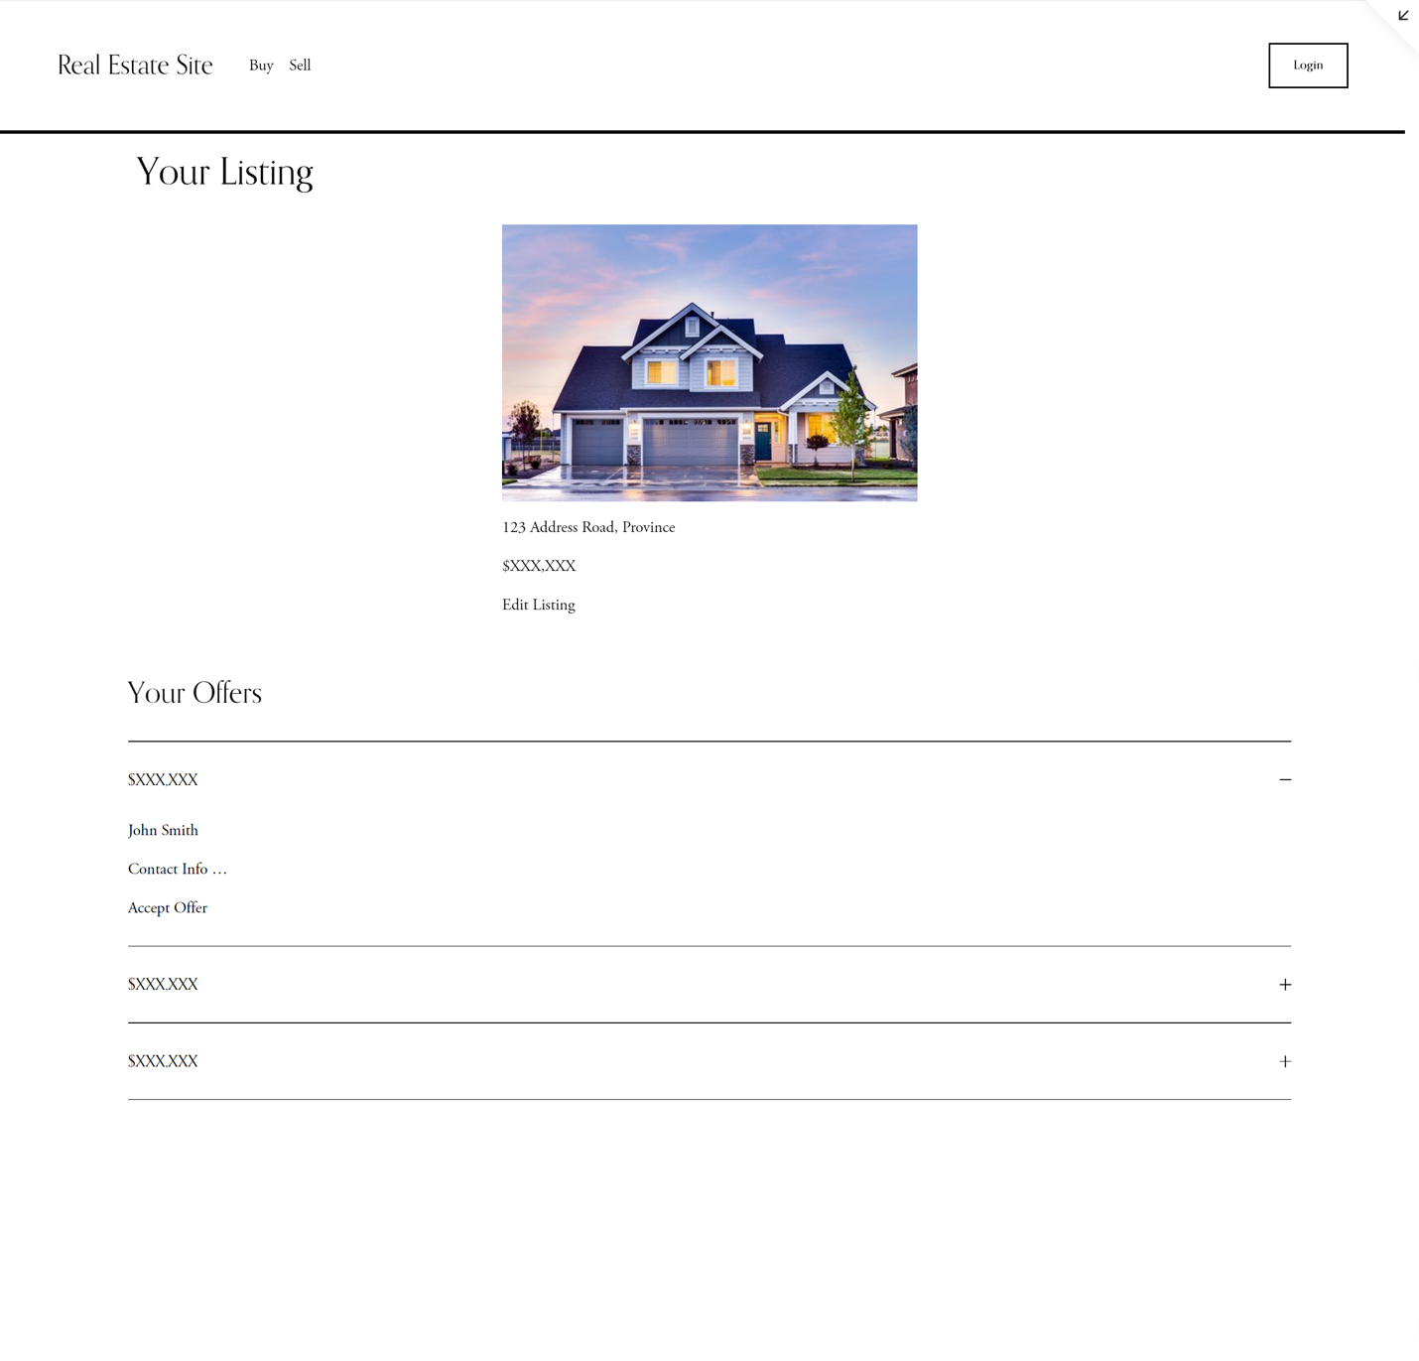

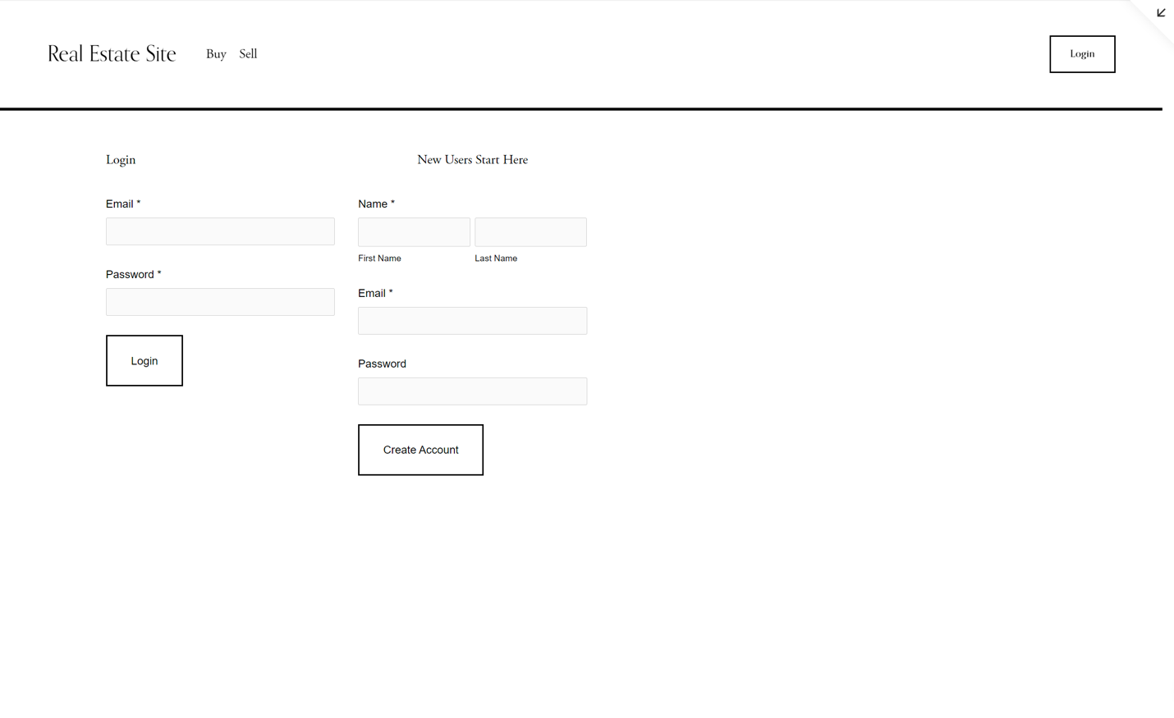Login/Signup

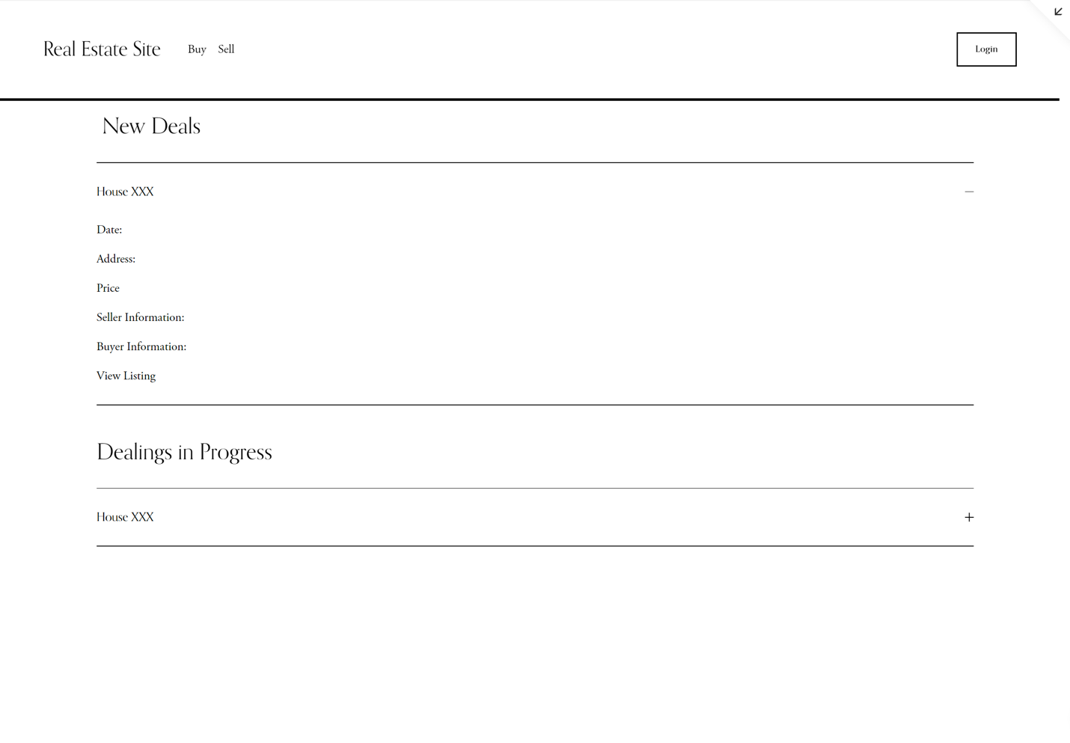Real Estate Agent’s Page

Rationale

We decided to design a simple webpage interface as less than half of our responses stated that they were good with technology. This is further justified as more than half of the people stated their primary device was a phone so a streamlined page would display more easily on a mobile device.

Our home page is a landing page with information about the site as having the home page set to the buy page would potentially alienate sellers. The buy page has an interactable map that is minimized at first and the search filters are also hidden so users are not overwhelmed at first. The map will work similarly to Zillow’s site, having a map alongside the page of listings. The map was included as almost all participates stated that location is important, though we were weary as Fairsquare showed that a map feature must be well implemented in order to be helpful. In the actual implementation, the listings will have icons representing size, bedrooms and bathrooms and their values in addition to just the address and size, similar to Fairsquare’s listing. In addition, it would have a button for signed in users to save or favourite a listing. We would also like to implement hover to peak function whereby hovering over a listing, you would be able to see more details to the listing without having to open its page.

The individual listings page starts out with slideshow of pictures. While Zillow’s 3D Tour feature would be incredibly useful, it would not be feasible to implement. Instead, videos could be included with the photos. A description by the current owner helps provided further understanding of the home and perhaps the feelings that the house invokes. In the actual implementation, icons would replace the words of the different amenities, similar to Zillow and Fairsquare. This is to avoid massive walls of text like with Purple Bricks and make it easier for users to scan through, saving time. Many people surveyed indicated they did not have a lot of free time, so they are unlike to read pages of text per house. In addition, there is a calendar for people to easily plan out open houses to visit. As mentioned earlier, location is important, so another interactable map is included as well as a list of nearby points of interests such as schools and shops.

As this site is designed for do-it-yourself, a simple form is provided for sellers to create their own listing. As many people interested in selling online are interested in saving money, users will provide all the data to avoid paying agents to do so. Contact information and house details are asked for, though this storyboard only showing some of the fields that would be on the form. It could be further improved upon with drop downs to divide questions that could be grouped together. The site will allow users to upload pictures of the house. For security reasons, the user will have to upload proof of ownership to prove that the home is theirs to sell. In addition, listings will be manually approved before being added to the site. After a seller’s posting is approved, their listing will show up under their “your listings” page. Here they will be able to edit their listing as well as see the offers those buyers have made.

In addition, there is a simple login and sign-up page as accounts would be necessary for the site to work. Real estate agents would have a site to view deals that they are managing. It would give them access to the home information and information of the buyer and seller for them to complete any paperwork. In the final version, there would also be a saved listing page for buyers to browse listings that they wish to come back to. They would also be able to access preferences such as a dark mode.